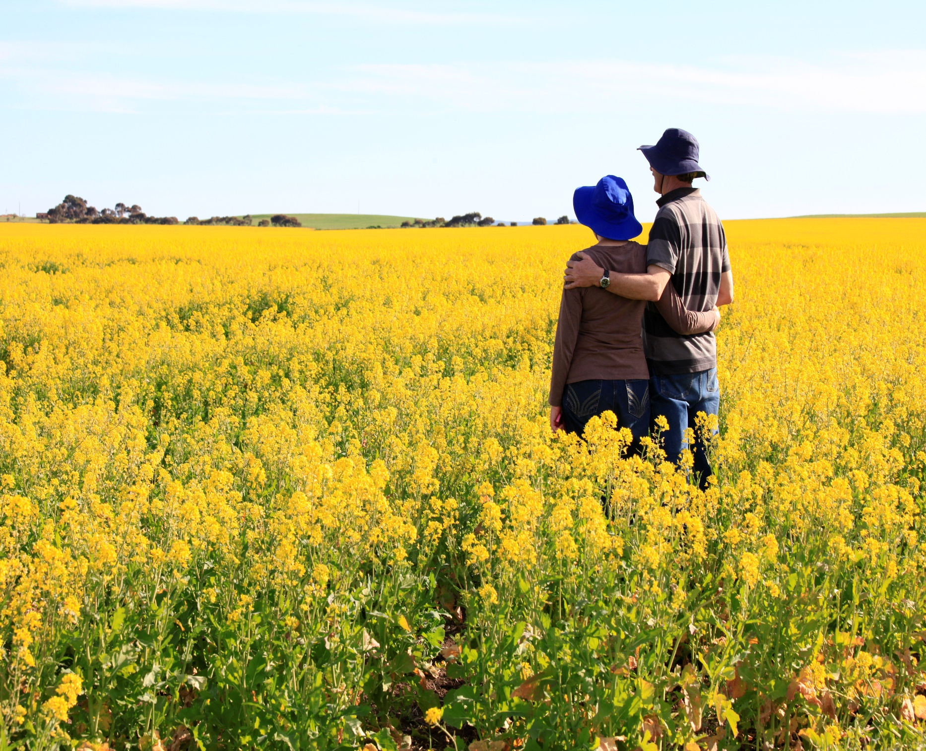

REGIONAL COUNCIL OF GOYDER
PROVISIONAL
DISABILITY ACCESS AND INCLUSION
PLAN-

2020-2024

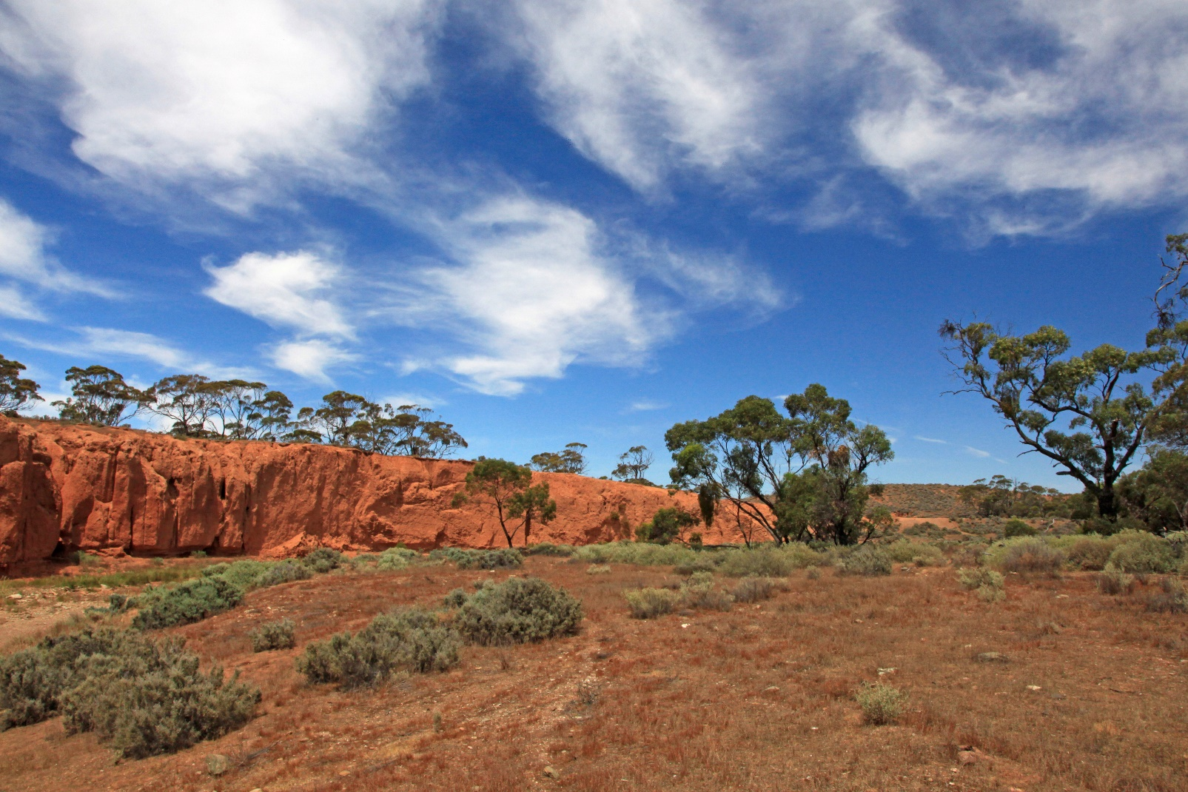
Red Banks Conservation Park

Acknowledgement of Country
The Regional Council of Goyder would like to acknowledge the Ngadjuri People, the traditional owners of the land on which we meet today and pay their respects to their Elders past, present and emerging and extend that respect to other Aboriginal or Torres Strait Islander people who may be present today.

CONTENTS

Part 1- Introduction
  - Regional Council of Goyder’s commitment to a DAIP

Part 2- Strategic Context
2.1 International and National strategic alignment of the DAIP

Part 3- About Us
3.1 Regional Council of Goyder’s Vision
3.2 Strategic Direction of Council
3.3 The Regional Council of Goyder- A Snapshot
3.4 Demographic Profile
3.5 Disability Demographics

Part 4- Our Community Voice
4.1 Consultation Process
4.2 Key Findings
4.3 Community Priorities

Part 5- Goyder Action Plan 2020-2024
5.1 Inclusive Communities for all
5.2 Leadership and Collaboration
5.3 Accessible Communities
5.4 Learning and Collaboration
5.5 Delivery, Monitor, Review and Evaluation of the Goyder DAIP

- INTRODUCTION
The Regional Council of Goyder has developed its first Disability Access and Inclusion Plan (DAIP) for our region.
Developing a Disability Access and Inclusion (DAIP) plan demonstrates the Regional Council of Goyder’s commitment to improving the participation of people with disability, their families and carers across a range of areas, so they can enjoy the rights and opportunities provided to all citizens and reach their full potential.

This plan identifies and addresses barriers to inclusion and aims to identify and action improvements that will achieve accessible and inclusive communities, agencies and practices for people living with disability in the Goyder region.
Through the DAIP Council aims to:
- Create welcoming and inclusive practices and culture

- Provide ways for people with disability to contribute to decision making and community leadership

- Improve accessibility to Council facilities, services, events and information

- Support employment and career development opportunities in our region.

This DAIP is a living document, developed through extensive community consultation, and its actions will be reviewed yearly to ensure that Council is continuing to work to improve access and inclusion through implementing the actions set out in this plan.

Council recognises it has a leadership role in providing supportive and accessible environments and services to its community. This DAIP aims to ensure Council is accessible to, and inclusive of, people living with disability.

The Regional Council of Goyder would like to thank everyone who took part in the creation of this plan especially our residents living with a disability, their families and supporters who shared their personal stories and visions for the region. As well as the community hosts for all our listening posts, service providers, community groups, interested community members, and Elected Members and Council staff for their feedback.

Your diverse voices have shaped the Goyder Disability Access and Inclusion Plan 2020-2024.

- STRATEGIC CONTEXT

The Goyder Disability Access and Inclusion Plan 2020-2024 has been developed with consideration given to the various legislation, strategies and plans developed to support and promote access and inclusion for people living with a disability. The International and National strategic alignment of the Disability Access and Inclusion Plan includes:

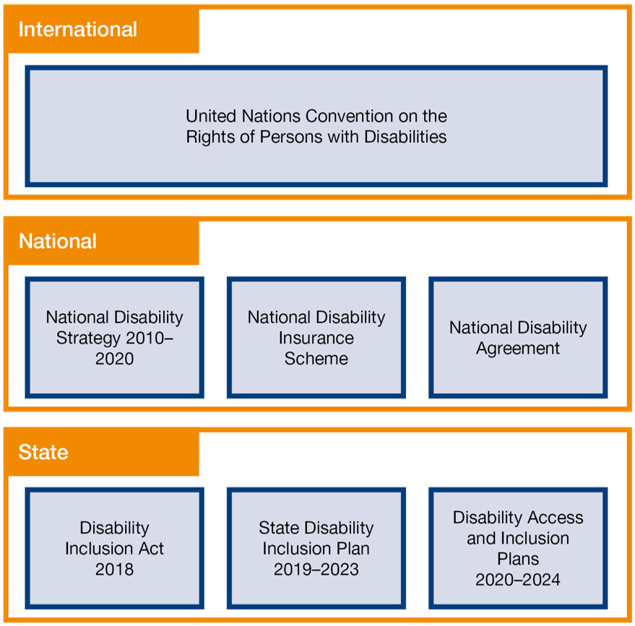

Disability Access and Inclusion Plan (DAIP) Guideline- Guidelines for South Australian State Authorities, Government of South Australia Department of Human Services

In 2018, the Disability Inclusion Act 2018 (SA) (the Act) was passed because the South Australian Government recognised that a stronger commitment to access and inclusion planning for people living with disability was needed.
The Act supports the United Nations Convention on the Rights of Persons with Disabilities (UNCRPD), acknowledging that people living with disability have the same human rights as other members of the community and that the State and the community have a responsibility to facilitate the exercise of those rights.
The National Disability Strategy (NDS) is a coordinated plan across all levels of government to improve the lives of people living with disability, their families and carers. The NDS is Australia’s response to the UNCRPD and is designed to ensure the principles of the UNCRPD are incorporated into policies and programs across Australia. Currently, the Commonwealth, State and Territory Governments are working towards developing a new national disability strategy for beyond 2020.
The Goyder Disability Access and Inclusion Plan 2020-2024 has been developed around the themes and priority areas set out in the Inclusive SA: State Disability Inclusion Plan 2019 – 2023 (the State Plan) which was released on 31 October 2019.
The themes within the State Plan and the Goyder Plan are:
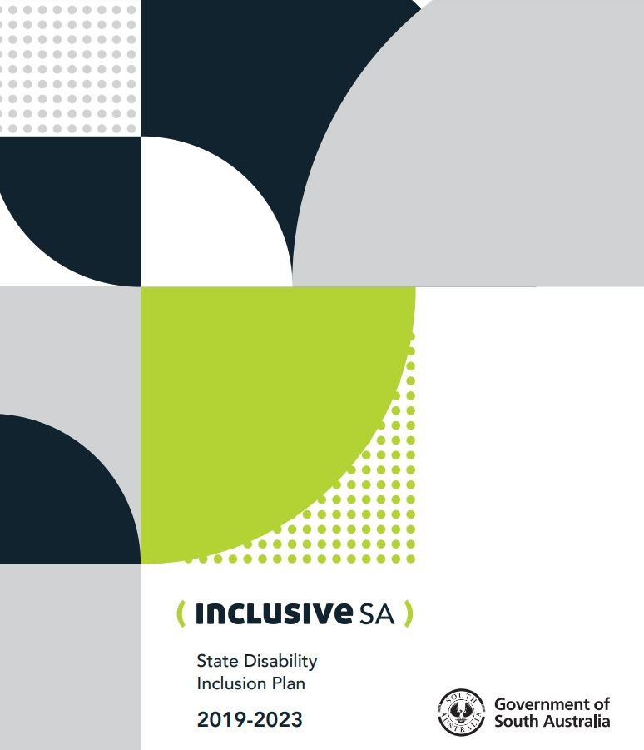
- Inclusive communities for all
- Leadership and collaboration
- Accessible communities
- Learning and employment.

- ABOUT US

3.1 The Vision of the Regional Council of Goyder

The vision and role of the Regional Council of Goyder demonstrates the importance of, and the role Council plays in, creating inclusive, healthy and resilient communities.

ONE GOYDER: A united and vibrant community that embraces change and is characterized by strong and responsive leadership

The Role of the Regional Council of Goyder is to:

- Provide strong leadership to our community and advocate on their behalf to improve access to the services and infrastructure they need.

- Actively listen to community and respond appropriately through clear and timely communication. Council will be approachable, demonstrating understanding and cooperation.

- Be transparent and honest in decision making and demonstrate integrity through our efficient and responsible use of resources

- Support the growth and development of our communities through our forward thinking and positive attitudes

3.2 Strategic Direction of Council

The Goyder Master Plan is Council’s overarching community strategic plan which through consultation with local community, has produced a series of goals dedicated to improving the Goyder region. The Goyder Master Plan is structured over a fifteen (15) year period, reviewed yearly and is guided by six pillars which provide priority strategic priorities for Council to assist in the delivery, monitoring and review of the plan. This Goyder Disability Access and Inclusion Plan 2020-2024 will be become part of the Goyder Master Plan and its actions will be reflected within the pillars below.

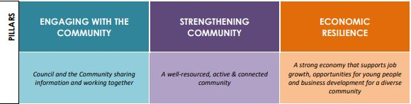
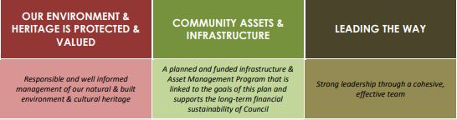

Relationship to other policies, strategies, frameworks

The actions developed within this Disability Access and Inclusion Plan will also be actively considered in the development, delivery and review of Council’s other strategies, plans, policies and procedures.

By doing this we ensure the commitment that Council has made to ensure that the DAIP supports decision-making and that issues of access and inclusion are considered in all areas of service delivery.

Key Council plans and strategic documents include-

Annual Business Plan, Budget and Long Term Financial Plan
Art Development Strategy
Conservation Management Plan
Goyder Tourism Strategic Plan
Regional Public Health Plan

  - The Regional Council of Goyder- A Snapshot

The Regional Council of Goyder covers an area of 6,681 km2 within the Mid North of South Australia. The region extends from south of Eudunda to North of Terowie. Our population of 4,206 people live in ten main townships, smaller settlements and the surrounding rural hinterland.

The Goyder region is renowned for its cereal crops, wool, sheep, cattle and other livestock production as well as its preserved mining and pastoral heritage. The National Heritage Listed town of Burra draws visitors from all over the world seeking to experience the built heritage and history of the copper mining era.

The Council area is named after George Woodroffe Goyder, whose famous Goyder’s Line crosses the Council area, distinguishing climatic zones which have influenced settlement patterns and continue to impact on the nature of agricultural and pastoral enterprises. Farming continues to be the most significant contributor to the Goyder economy.

The larger townships of Eudunda and Burra are served with hospitals, schools, recreation and sporting facilities and community meeting places. Many of the smaller townships no longer have primary schools and so their remaining community facilities such as hotels, general stores, halls, post offices and playgrounds provide a very important focus for the local community.Towns such as Booborowie and Robertstown regard the retention of their primary schools as critically important to retaining their existing population and to attract new residents to the area.
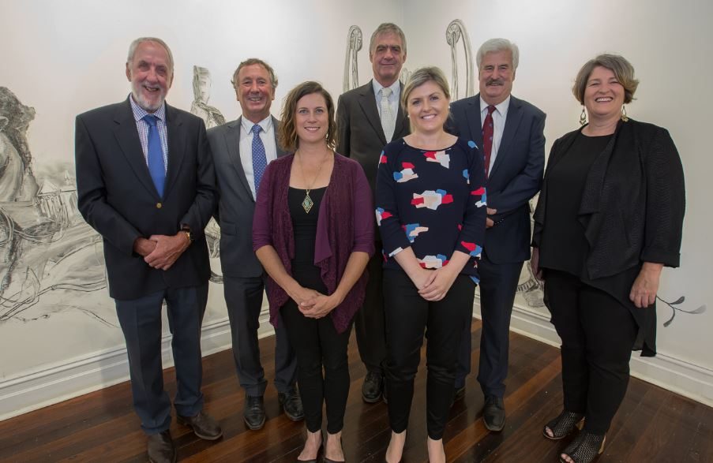
The elected Council comprises of the Mayor and 6 Ward Councilors, with Council responsible for a diverse range of services including tourism facilities, parks and gardens, community facilities, road infrastructure, regulatory services, street lighting, town planning, building approvals, events, sports and recreation development, arts and cultural development, public health and information services.
Left to Right- Deputy Mayor John Neal, Cr Bill Gebhardt, Cr Debbie Hibbert,
Cr Peter Schiller, Cr Heidi Thompson, Mayor Peter Mattey OAM and Cr Jane Kellock

The Council comprises of four Wards - Burra, Eudunda, Hallett and Robertstown:

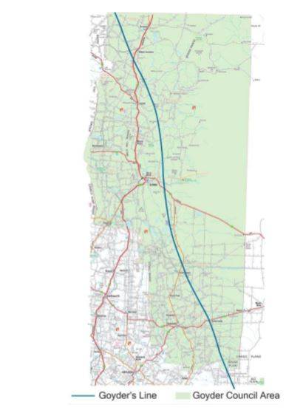

3.4 Demographic Profile

The Census resident population of Regional Council of Goyder in 2016 was 4,136, living in 2,212 dwellings with an average household size of 2.23. There is quite an even split between gender of residents with 50.2 % (2079) male and 49.8 % (2059) female.

Council acknowledges the risks that relate to priority groups living with disability: women, children, Aboriginal and Torres Strait Islander people and culturally and linguistically diverse people.

According to the 2016 Census:

There were 69 Aboriginal and Torres Strait Islander residents in the Goyder region.

81.4% percent of residents were born in Australia with only 1.9 percent of people speaking a language other than English at home.

Analysis of the age groups of Regional Council of Goyder in 2016 compared to South Australia shows that there was a similar proportion of people in the younger age groups (0 to 17 years) and a higher proportion of people in the older age groups (60+ years).
Overall, 20.9% of the population was aged between 0 and 17, and 31.0% were aged 60 years and over, compared with 21.0% and 24.4% respectively for South Australia.

3.5 Disability Profile

In 2016, 269 people (or 6.5% of the population) in Regional Council of Goyder reported needing help in their day-to-day lives due to disability. This was a similar percentage to 2011.

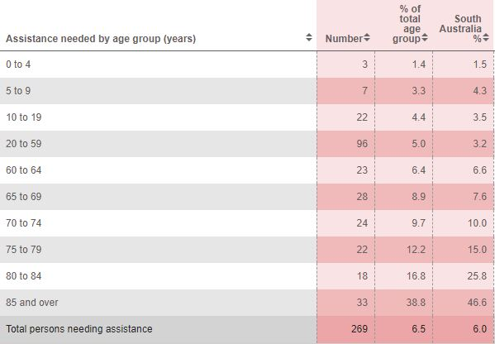

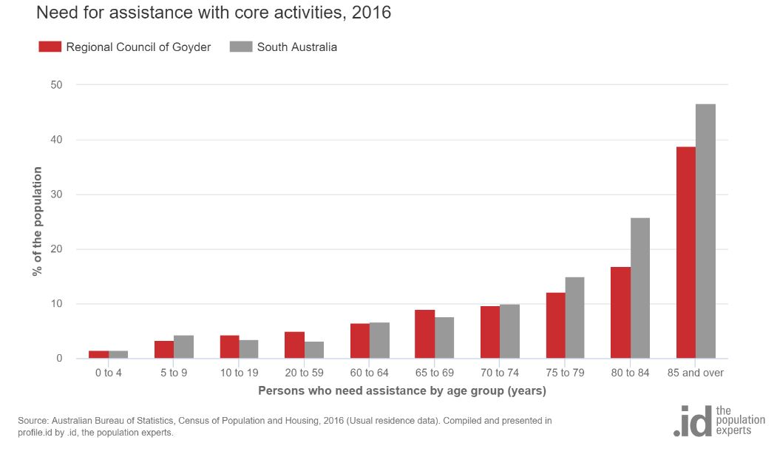

The National Disability Insurance Scheme (NDIS) is a fundamental reform to the delivery of disability care.

As at the 1 July 2018, in Goyder there were-
0% CALD Current Clients
7% Indigenous Current Clients
40% Current Client Gender (Female)
60% Current Client Gender (Male)
26% Child Current Clients
Most new entrants were between the ages of 45-64

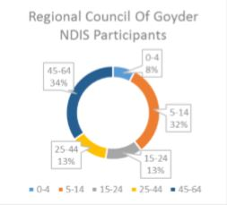
Disability Workforce Project- Regional Development Australia Yorke and Mid North 2018

- OUR COMMUNITY’S VOICE

The Regional Council of Goyder is committed to ensuring that community engagement is integrated into all Council activities to support decision making, building relationships and strengthening communities.

Community engagement is the responsibility of all Councils service areas, team and employees. Council will advocate for its community and ensure that the community views, needs and concerns are raised with other levels of government or relevant stake holders.

5.1 Consultation Process

The Goyder DAIP was developed through consultation with the community, Council management and staff, Elected Members, disability service providers and local community groups, organisations and interested residents/businesses.

Council’s commitment to the DAIP meant that it was essential that authentic and genuine engagement with people with disability (their families and carers) occurred from the very beginning of its development. We wanted to ensure that Council “walks the talk”.

Whilst being challenged by public gathering restrictions related to the COVID-19 pandemic, the Regional Council of Goyder provided diverse ways for residents to be able to share their thoughts and ideas during the initial consultation process.

The extensive consultation process over a period of four weeks saw the following opportunities take place in the Goyder region-
1. Community Survey- Online and hardcopy surveys were available for a period of 4 weeks
2. Community Listening Posts- 1:1 chats with Council held in 5 smaller towns at central community spaces such as community centre, general stores and post offices over a period of a week.
3. Community Forums-Four Community Forums in total were held in Eudunda (2 forums) and Burra (2 forums) both morning and evening sessions to provide options for community to attend.
4. Chat with a local Disability Consultant- A local Disability Consultant was available to have a chat with community over the phone or in person.
5. Presentation to Elected Members- Ordinary Council Meeting September 15 2020
6. Presentation to Council staff- Administration Meeting August 27 2020

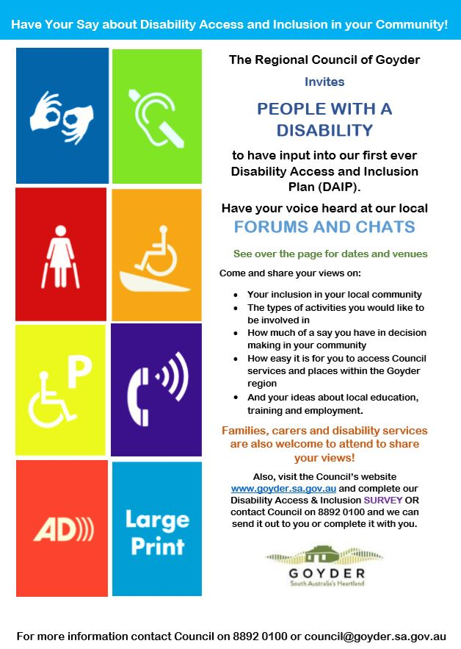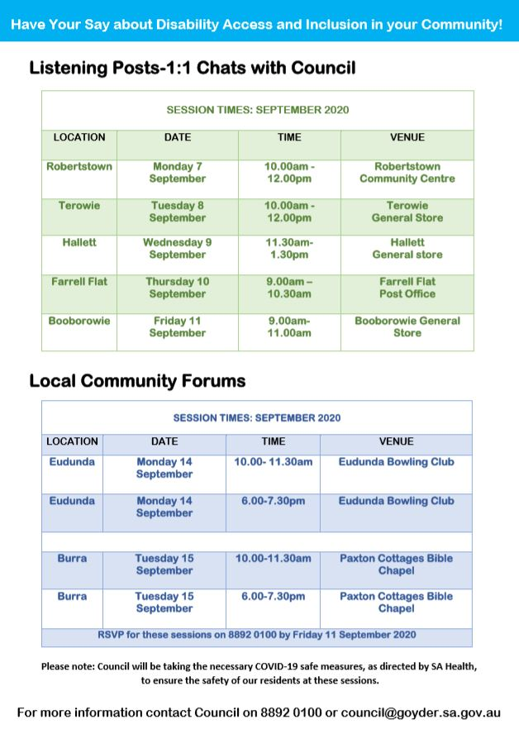
Consultation was promoted through the Council website, social media, local newspapers, council newsletter, community noticeboards and digital engagement campaigns.
Local community groups, disability services, businesses and key stakeholders such as schools were directly contacted to seek input and submissions towards this plan.

SEPTEMBER 2020 1:1 LISTENING POSTS AND COMMUNITY FORUMS

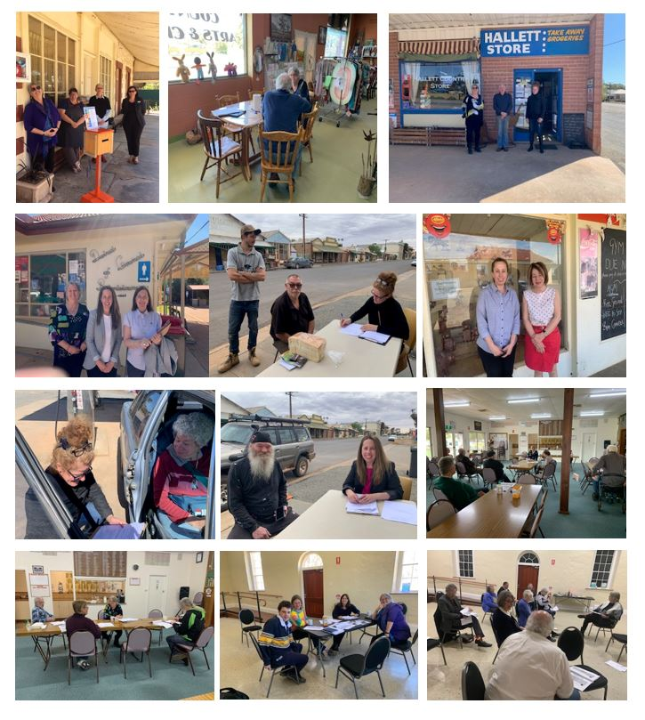

4.2 Key Statistical Data from the 101 Online Survey participants

Survey Respondents
Graph 1: About the Respondents (N=101)
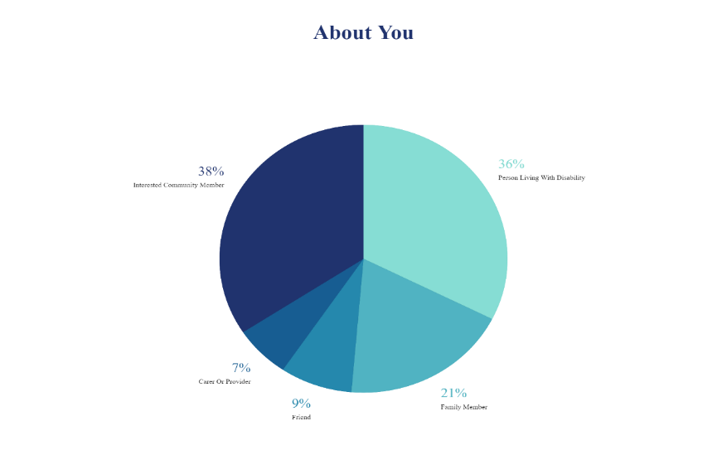

Of the 101 respondents who undertook the survey, 36% were persons living with disability; 21% a family member; 9% a friend of a person living with disability; 38% were interested people in the community; and further 7% were either a carer or service provider.

Age Brackets of Respondents
Graph 2: Age Brackets
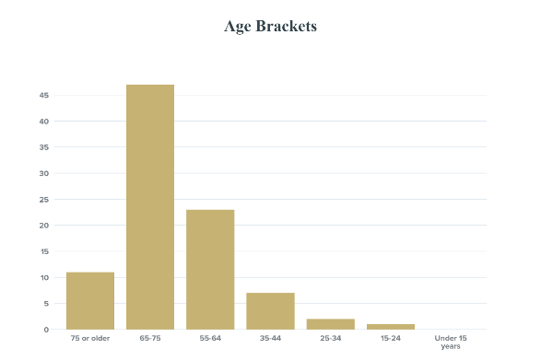
Most survey respondents were aged between 65-74 (47%), with other age brackets indicated as follows: 23% between 55-64; 10% over 75, 9% between 45-54; 7% 35-44; with only 2% 25-34 years and 1% being 15-24 years. No responses were received from under 15 year olds. Note, the median age of persons living in the Goyder region is 49 years (Australian Bureau of Statistics).

Gender

59% of the survey respondents were female, with 41% being male. One respondent preferred not to answer.

Nature of Disability
Graph: 3 Nature of Disability

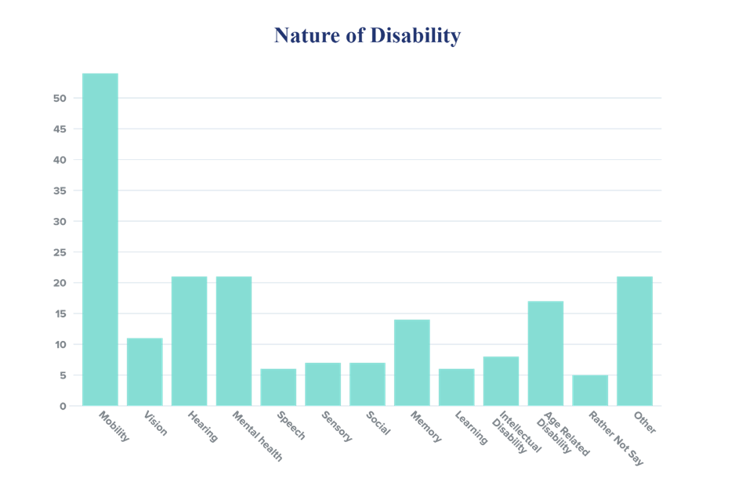

Mobility issues were the main disability challenge for more than half the respondents (54%), followed by both Mental Health (21%) and Hearing (21%) respectively. Other categories were broken down statistically as follows: Vision 11%; Sensory 6%; Social 7%; Memory 14%; Learning 6%; Intellectual Disability 8%; Age Related Disability 17%; Rather not say (5%) and Other (23%).

Participating Townships in the Goyder Region

The survey respondents were spread across the Goyder region as follows: Booborowie 11%; Bower 1%; Burra 12%; Eudunda 27%; Farrell Flat 12%; Hallett 7%; Mt Bryan 1%; Robertstown 16%; Terowie 13% and Whyte Yarcowie 1%. One respondent identified as residing in Point Pass.

Employment & Training

Most survey respondents were retired (47%), with a further 30% of people currently employed and 18% unemployed. 8% of those currently unemployed indicated that they would like to have a job. 54% of respondents (n=90) indicated that they would like to undertake disability support work either now (33%) or at some time in the future (21%) if they had the opportunity, skills and confidence to support a person living with disability in their community.

4.3 Community Priorities from 1:1 Listening Posts sessions and Forums

THEME 1: INCLUSIVE COMMUNITIES FOR ALL
Transport & Services: Lack of transport options for communities and for people living with disability, in particular, to attend medical appointments, to shop and/or to socialise, was a recurring theme, as was a lack of local services.

Social Isolation: Social isolation was mentioned by people often as a challenge for people living with disability. Lack of transport was a contributing factor to that social isolation but there were many other factors as well, including a tendency not to want to engage and a lack of social supports (e.g., friendships).

Lack of Activity Options: Recognising that social isolation was a factor for many in the region, comments were made about the lack of activities available and suggestions were made as to how to help support more engagement in community (e.g., have a friend/mentor accompany a person living with disability to an activity or event).
THEME 2- LEADERSHIP AND COLLABORATION
Ideas were generated by residents under this category to be able to engage people living with disability and their families more in the community. For example, activities such as Skateboard mentoring and soccer programs for young people were suggested. Other activities recommended were Arts training for people living with disability (e.g., arts and dementia SA Art Gallery); introduction to farming for young people; grants for upgrading IT equipment; upskilling and digital programs; IT aids to help people living with disability, awards to local businesses that help people living with disability with easy access; and to have disability access and inclusion be placed on the agendas of local town committee meetings.
THEME 3- ACCESSIBLE COMMUNITIES
Footpaths in poor condition were, by far, the most repeated ‘anthem’ from participants in the Listening Posts across the region. Other concerns were lack of ramp access from the roads to the footpaths; and the need for more appropriate parking, including more Accessible Disability Toilets.
THEME 4- LEARNING AND EMPLOYMENT
While most people living with disability were not engaged in learning and employment, interest was raised in the prospect of engagement, and ideas were generated around local training, upskilling in IT and locally based apprenticeships for young people with disability.

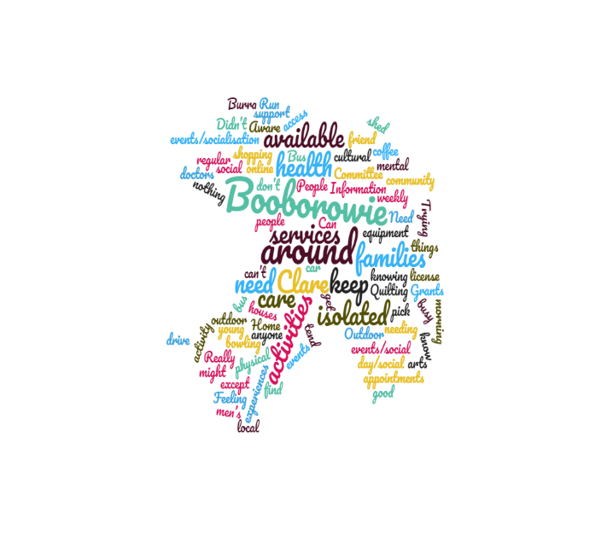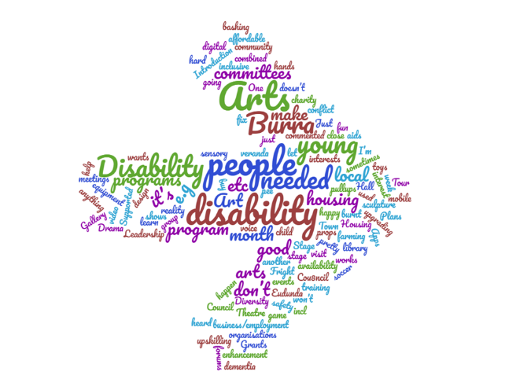

GOYDER’S PLAN FOR ACTION

2020-2024

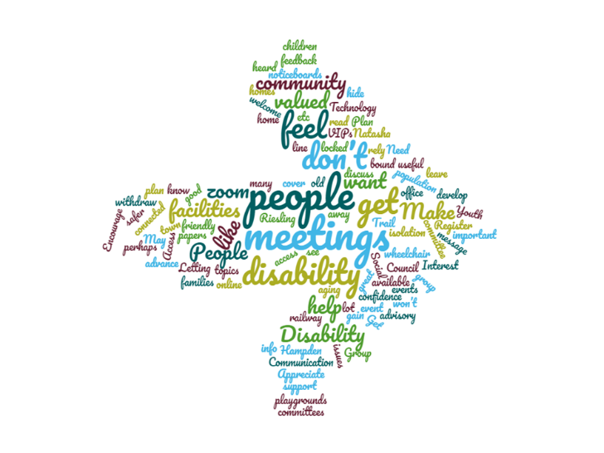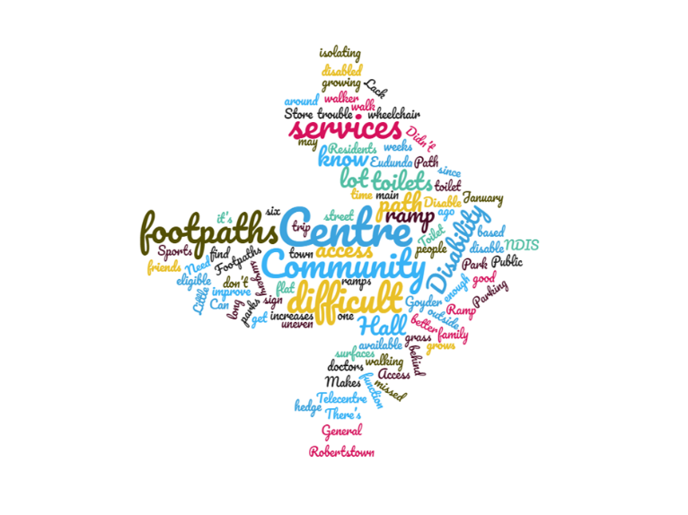

PART 5- PLAN FOR ACTION 2020-2024

5.1 Inclusive Communities for all

Social inclusion is a priority for people living with disability as it affects all aspects of their lives. It is our aim that the contributions and rights of people living with disability are valued and understood by all South Australians and that their rights are promoted, upheld and protected. We also want to ensure that people living with disability are supported to advocate for their own rights.

Priority 1: Involvement in the Community
Priority 2: Improving community understanding and awareness
Priority 3: Promoting the rights of people living with disability

ACTION | STATE PRIORITY # | DELIVERABLES | WHO | TIME-FRAME | MEASURABLE TARGET
Encourage the engagement of people living with disability in local clubs and social activities. | Priority 1 | Identify and collate local community groups and activities in the region. | Community Development Team | Short term  (2020-2022) | List of local clubs and social activities promoted on the Goyder Council website.
Local NDIS, Community, Disability and Health service providers to share relevant information to Council for sharing on website, newsletter, front desks and social media. | Priority 1 | Development of a local services contact list.  Information provided to services on how information can be shared to local community.  Expressions of interest sought to develop a local disability and health services expo in the region.  Action also included in the new Regional Public Health Plan 2020-2024. | Customer service team  Community Development Team  Elected Members | Short term  (2020-2022) | Information shared regularly through Council communications to community.  Customer service team able to direct community enquiries effectively to local services and organisations.  Local health and services expo to be held in the region.
Disability access and Inclusion reflected within the new Goyder Arts Development Strategy. | Priority 1 | People living with disability actively involved in the community consultation process.  Exploring options to further build the capacity of local artists with disability in their practices through grant applications, exhibitions, performances etc.  Work with community and arts groups to create welcoming and inclusive environments to support locally based experiences for people living with disability. | Arts and Cultural Facilitator  Country Arts SA | Long Term  (2020-2024) | Disability access and Inclusion reflected within the new Goyder Arts Development Strategy.
Progressively review Council’s application forms, asset management plans, and policies to ensure that disability access and inclusion is considered. | Priority 2 | During the review or development of each form, plan and policy staff consider what needs to be included to ensure that disability access and inclusion is promoted. | Senior Management Team  All Staff | Long Term  (2020-2024) | New polices, plans and application forms developed will consider/ reflect disability access and inclusion.
Disability Access and Inclusion information such as accessible car parking and toilets, will be provided in the promotion of all Council’s future events. | Priority 3 | Promotion for events will now display information about disability access to welcome and support the inclusion of people living with disability, their families, friends and carers at these events.  . | Community Development Team  Governance | Short Term  (2020-2022) | All event promotional material from Council will provide easy to read information about disability access and inclusion.
Assisting local sporting clubs and community associations to adopt inclusive policies and programs. | Priority 3 | Supporting local sporting clubs and community associations to adopt inclusive programs and practices as guided by their State sporting offices and Inclusive Sport SA.  Promote Inclusive Sport SA programs and grants. | Sports Development officer | Long term  (2020-2024) | List of local sporting and associations on the Council website that are inclusive within their policies and delivery of programs.
A disability focussed webpage will be created on the Council website so as to provide easy to read information which provides access to the DAIP, promotes the rights of people living with disability and identifies avenues for feedback to Council regarding disability access and inclusion. | Priority 3 | Development of web page on Council website. | Governance  Community Development Team | Short Term  (2020-2022) | A webpage called “Disability Access and Inclusion” is created on the Council website.

5.2 Leadership and Collaboration

People living with disability want to have a greater role in leading and contributing to government and community decision-making. It is our aim that the perspectives of people living with disability are actively sought and that they are supported to participate meaningfully in government and community consultation and engagement activities

Priority 4: Participation in decision-making
Priority 5: Leadership and raising profile
Priority 6: Engagement and Consultation

ACTION | STATE PRIORITY  # | DELIVERABLES | WHO | TIME-FRAME | MEASUREABLE TARGET
Introduction of local town Listening Posts, as part of community consultation processes to ensure people living with disabilities have direct input into Council decision-making. | Priority 4 | Listening posts will take place in central spaces and places in towns such as post offices, general stores & community centres to provide opportunities for 1:1 conversations with Council to help increase community engagement in decision-making. | Elected Members  All Interested Staff to be involved | Short Term  (2020-2022) | Listening posts will take place in a minimum of 5 towns each year as part of the Council’s community feedback consultation process.
Develop a Council communication strategy to better engage children and young people, especially those living with disability and their families, in local decision- making. | Priority 4 | Discussions at a local level with-  Goyder YAC  Playgroups  Early Learning Centre  Schools  Sporting & Recreational Groups  NDIS  Early Intervention and Youth services | Community Development Team  All staff &  Elected Members | Short Term  (2020-2022) | Development of a communication strategy that identifies how Council will communicate and engage with young people living with disability in the Goyder region.
Goyder Master Plan to include key actions from within the Goyder Disability Access and Inclusion Plan. | Priority 4 | Review of Goyder Master Plan in 2021 will include key actions and feedback from DAIP community consultations. | CEO  Governance | Short Term (2020-2022) | Goyder Master Plan (2021-2036) promotes community and strategic goals for disability access and inclusion in the region.
To establish a Goyder Disability Advisory Group to support to monitor and provide review on the Goyder Disability Access and Inclusion Plan. | Priority 5 | Expression of interest process to community for a minimum of 4 and up to 7 community representatives living with a disability (minimum of one from each Council Ward) to become members of a Goyder Disability Advisory Group.  Terms of reference for the group is developed. | Elected Members  CEO and Senior Management Team  Council Staff | Short term  (2020-2022) | The establishment of a Goyder Disability Advisory Group.  The advisory group meets twice a year to review and provide feedback to the Goyder DAIP with key Council staff.
Increase the engagement of Aboriginal and Torres Strait Islander peoples, especially the Ngadjuri Board, within the delivery and further consultation and development of the DAIP. | Priority 6 | Further development of relationships with the Ngadjuri Nation Aboriginal corporation to identify priorities related to disability access and inclusion.  Delivery of Cultural Awareness workshop to Council staff and Elected Members.  Develop networks with local Aboriginal support services. | Elected Members  CEO  All Staff | Long Term  (2020-2024) | Increased Ngadjuri voice within the future review and development of the Goyder DAIP.
Provision of Council information to community in easy to read format ensuring and, when appropriate, distributed through letterbox mail to ensure wider community reach. | Priority 6 | Progressive review of current information to ensure accessible & easy to read information about Council services.  Guidelines created to support Council staff to consider easy to read format when formally communicating with the community. | Senior Management Team  All departments | Long Term  (2020-2024) | Guidelines created to support easy to read communication and information.  Quarterly Council newsletter posted out to all residents.

5.3 Accessible Communities

The accessibility of the built environment, quality services and information is key to ensuring people living with disability are included and have the opportunity to equally participate in all aspects of community life. It is our aim to increase accessibility to public and community infrastructure, transport, services, information, sport and recreation and the greater community.

Priority 7: Universal Design across South Australia
Priority 8: Accessible and available information
Priority 9: Access to services

ACTION | STATE PRIORITY  # | DELIVERABLES | WHO | TIME-FRAME | MEASUREABLE TARGET
To develop a footpath construction and/or renewal program that identifies key priorities including footpaths identified through the DAIP community consultation process. | Priority 7 | To review current footpath condition data at Council.  To map out footpath networks across the region and identify priorities. | Director of Infrastructure  Technical services and work department | Long Term  (2020-2024) | The development of a Footpath Construction/  Renewal program which includes footpaths identified through the DAIP community consultation.
Review main street access to local businesses in Burra and Eudunda to identify areas of improvement including the provision of handrails. | Priority 7 | Audit of main street access to determine specific problem areas and development of plan and budget for the provision of handrails where required. | Director of Infrastructure  Technical services and work department | Long term  (2020-2024) | Review of main street access in Burra and Eudunda and the provision of handrails in each main street to assist access for people living with disabilities and the elderly.
Audit of current disabled parking facilities in the Goyder region. | Priority 7 | Audit of current disabled parking facilities in the Goyder region to determine whether there is sufficient parking available in Main Street and at Council owned facilities. | Director of Infrastructure  Technical services and work department | Long term  (2020-2024) | Audit of current disabled parking facilities completed and any gaps in access to disabled parking identified.
Embed access and inclusion and universal design principles in new development, decision-making and budgetary processes. | Priority 7 | Management of existing assets.  Audit and review of disability access and areas for improvement for current facilities. | Elected Members  Senior Management team  Technical services and works  All Staff | Long Term  (2020-2024 | Staff upskilled in universal design principles.
Distribute to new residents a Goyder Council welcome pack including information on Council & local services, clubs and activities, disability access and inclusion. | Priority 8 | An updated welcome pack will be created and be made available at Council office, agencies and post offices/general stores. | Customer service  team | Short term  (2020-2022) | Each new resident will have access to a Goyder Council welcome pack.
Audit of current signage in the region to ensure effective wayfinding signage and documents such as maps to support access to facilities for people living with disability. | Priority 8 | Undertake audit of current signage and wayfinding materials that supports access for people with disabilities to facilities and services in the region. | All Staff | Long term  (2020-2024) | Review undertaken of current signage and wayfinding supportive material such as maps to identify where there are gaps of information/sign-age.
Ensure the Council’s Customer Service Charter and Community Engagement Charter reflects the Disability Access and Inclusion Plan and including responding to Minor Works Request. | Priority 8 | Review of the current Customer Service Charter and Community Engagement Charter. | All staff and Elected Members | Short Term  (2020-2024) | Updated Council’s Customer Service Charter and Community Engagement Charter that reflects the Disability Access and Inclusion Plan.
Provision of easy to read information for visitors to the region around disability access including the Burra heritage passport sites that supports people living with disability in their holiday planning. | Priority 9 | To undertake an audit of the Burra Heritage Passport Sites to identify access challenges.  Identification of all disabled toilets and change rooms in the region.  Development of easy to read information that supports holiday planning. | Tourism and Events Coordinator  Burra Goyder Visitor Information Centre staff  Building asset manager  National Trust | Long term  (2020-2024) | Completed audit of accessibility to Burra heritage passport sites.  Information available to tourists/visitors that provides information on accessibility into each site on the website and at the Visitor Information Centre.
To identify opportunities where augmentative reality technology and other applications could be developed to improve access to tourist sites where access is currently not available. | Priority 9 | To undertake an audit of the Burra Heritage Passport Sites to identify access challenges. | Tourism and Events Coordinator | Long term  (2020-2024) | List of opportunities and costings developed of augmentative reality technology/apps in preparation for any future external grant opportunities.
Encourage local businesses and community groups to apply for grants that improve access and inclusion for people living with disability, their families and carers. | Priority 9 | Disability Awareness training for businesses.  Ongoing sharing of grant information with local businesses.  Sharing of local examples where access has been improved by local businesses/organisations- good news stories. | All Staff  Elected Members | Long Term  (2020-2024) | Disability Awareness Workshop held for businesses/ organisations as part of Business Breakfast series.
Undertake an audit of local transport options available in the Goyder region | Priority 9 | Identify transport options that are currently available and promote these services to the community.  Better promotion of the Mid North Passenger Network service across the region particularly in smaller towns | Community Development Team | Short Term (2020-2022) | Provide a list of transport options on the Council website for community access  Increased utilization of the Mid North passenger Network by 10 percent.
Encourage and advocate for, local transport and service providers to consider expanding available services in the region | Priority 9 | Meet with local services providing current transport to determine options for increasing/ accessing transport for the local community.  Council to consider transport options when planning events to support access of people living with a disability who do not have access to transport. | Elected Members  CEO  Community Development Team | Long term (2020-2024) | Meeting with local service providers to advocate for community needs for transport in the region particularly for social activity.

5.4 Learning and Collaboration

Workforce participation is fundamental to social inclusion. It provides economic independence and choice, social connections and friendships, value, identity and belonging. It is our aim that people living with disability have access to inclusive places of study and that education and training provides pathways to meaningful and inclusive employment and volunteering opportunities

Priority 10: Better support within educational and training settings
Priority 11: Skill development through volunteering and support in navigating the pathway between learning and earning
Priority 12: Improved Access to Employment opportunities and better support within workplaces.

ACTION | STATE PRIORITY  # | DELIVERABLES | WHO | TIME-FRAME | MEASUREABLE TARGET
Advocate to regional employment and training providers, businesses and other bodies, to consider opportunities for people living with disability to engage in local training, work experience, apprenticeships and employment. | Priority 10 | Connect with local training, NDIS and employment providers to advocate and explore locally based opportunities | CEO & Elected Members,  Human Resources,  Community Development team | Long Term  (2020-2024) | Provision of 2 workshops in the region about NDIS and opportunities of employment within the scheme as service providers.
Build volunteering and work experience opportunities between Council, the local schools and community groups to support the engagement of young people living with disability. | Priority 11 | Meet with the two area schools to discuss volunteering and work experience opportunities.  Create a model of best practice to support these opportunities. | CEO  Human Resources  Relevant Council staff  BGVIC staff | Long Term (2020-2024) | A model of best practice developed to support work experience and volunteering opportunities between Council and local schools.
Disability Awareness training will be provided for all Council staff, volunteers and Elected Members and will be included within the induction process. | Priority 12 | Council will seek out external training for people with lived experience to provide training to all staff and Elected Members to increase understanding of the rights of people living with disability and to support inclusive practices in the workplace. | Human Resources  Senior Management Team | Short Term  (2020-2024) | 90 percent of all staff, Council volunteers, and Elected Members have received Disability Awareness Training.

5.5 Delivery, Monitor, Review and Evaluation of the Goyder DAIP

The Regional Council of Goyder has responsibility for implementing, monitoring, reviewing and evaluating the Goyder DAIP 2020-2024.

The focus areas and strategies/actions of the DAIP will be integrated into the ongoing business planning of Council, including annual planning and budget processes, as well as the Goyder Master Plan.

The Regional Council of Goyder will follow an implementation cycle (displayed below) involving numerous stakeholders. The DAIP is subject to yearly review through milestone reporting and will be evaluated in 2024.

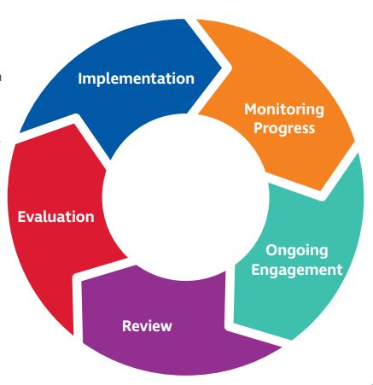

Ongoing Community Engagement

Council is committed to ongoing community engagement for this DAIP to be successfully implemented. Council will report on the DAIP actions on a yearly basis and provide an update to community in regards to progress and achievements. A Goyder Disability Advisory group will be formed to assist Council in achieving the outcomes of the DAIP by providing valuable lived experience feedback, ideas and evaluation. Community members are encouraged to continue to provide comment and input into the Goyder DAIP over the next four years so as to ensure ongoing reflection and development of best practice within all areas of Council to support improved disability access and inclusion in Goyder.

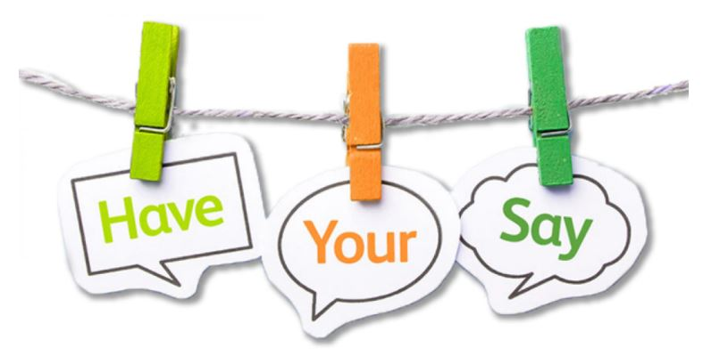

Provide your feedback to the PROVISIONAL Goyder Disability Access and Inclusion Plan 2020-2024

The Regional Council of Goyder is seeking feedback and comment to the PROVISIONAL Goyder Disability Access and Inclusion plan which will be included in the final document to be published on the 19th of November 2020.

You can contact us or provide feedback in a number of ways:

- In person by visiting our Council offices:
Burra- 1 Market Square, Burra (Open Mon-Fri 9am-5pm)
Eudunda- 25 Bruce Street, Eudunda (Open Tuesday-Thursday 9am-5pm)

Please note:
Wheelchair access is available at both offices
Accessible toilets are available at the Burra Council office

- By mail: 1 Market Square, Burra SA 5417

- By email: council@goyder.sa.gov.au

- Through online form: Visit our website www.goyder.sa.gov.au and submit online feedback form

- By phone: 8892 0100 (Burra) or 8581 1101 (Eudunda) during opening hours

